**Software Requirement Specification for myCardioMEMS Mobile Application (Android) Build and Deployment using Azure DevOps**

Table of Content

1. Introduction

          1.1 Purpose of this document

          1.2 Scope of this Document

1.3 Glossary

          1.4 Intended Audience and Reading Suggestions

1.5 References

 2. Overall description

2.1 Product Perspective

          2.2 Dependencies

2.3 Assumptions

3. System Features and Requirements

3.1 Functional Requirements

3.2 Non-Functional Requirements

**1. Introduction**

**1.1 Purpose of this document**

The purpose of this document for the implementation of Build and Release pipeline on Azure DevOps for myCardioMEMSMobile Application (Android).

**1.2 Scope of the Document**

This document describes specification and dependencies for the implementation of Build and Release pipeline for myCardioMEMS Mobile Application on Azure DevOps.

**1.3 Glossary**

|  |  |
| --- | --- |
| **Term** | **Definition** |
| DevOps | DevOps is the combination of cultural philosophies, practices, and tools that increases an organization’s ability to deliver applications and services at high velocity: evolving and improving products at a faster pace than organizations using traditional software development and infrastructure management processes. This speed enables organizations to better serve their customers and compete more effectively in the market. |
| Software Requirements Specification | A document that completely describes all of the functions of a proposed system and the constraints under which it must operate. |
| Self-Hosted Agent | An agent that you set up and manage on your own to run jobs is a self-hosted agent. You can use self-hosted agents in Azure DevOps Server. Self-hosted agents give you more control to install dependent software needed for your builds and deployments |

**1.4 Intended Audience and Reading Suggestions**

The document is intended for myCardioMEMS Mobile Application Dev/release and deployment teams.

**1.5 References for Azure Pipeline**

* <https://docs.microsoft.com/en-us/azure/devops/pipelines/ecosystems/android?view=azure-devops>
* <https://docs.microsoft.com/en-us/azure/devops/pipelines/get-started/what-is-azure-pipelines?view=azure-devops>

**2. Overall description**

**2.1 Product Perspective**

Need more info About myCardioMEMS Apps Details

**Azure DevOps**: Azure DevOps Services provides a platform for implementing the DevOps process across multiple IT segments. This tool supports the various practices under DevOps such as continuous planning, continuous development, continuous integration, continuous testing, continuous deployment/delivery, and continuous monitoring/feedback.

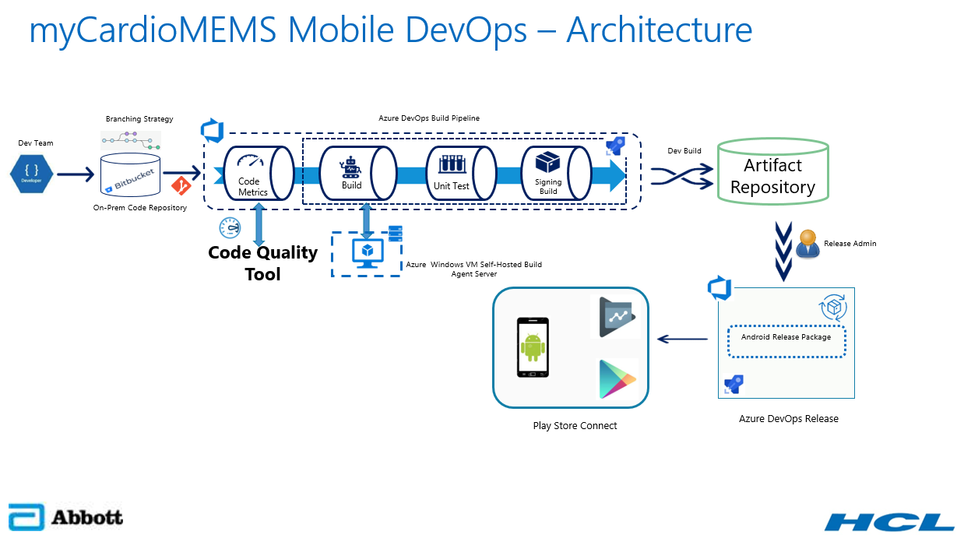

**Source Code Management (SCM): Bitbucket (OnPrem)**

Bitbucket is a Source Code Management Tool and self-managed solution that provides source code collaboration for professional teams of any size, across any distance.

On-Premises Bitbucket is the code repository configured within the organization infra network to check-in the code developed by the developers.

**Build Agent: Gradle**

Gradle is an open-source build automation tool that is based on the concept of Apache Maven and Apache Ant and focused on flexibility and performance. Gradle build scripts are written using a Groovy or Kotlin DSL.

For more Information, about Gradle - <https://docs.gradle.org/current/userguide/build_environment.html>

Gradle can be used to build the myCardioMEMS Mobile Application (Android) and generate a release package as Artifact (APK).

**Build Pipeline**

Whenever the developer triggers the DevOps pipeline manually, the Build process will start and publish the release package into Artifact Server.

Firstly, it will clone the code from on premises Bitbucket then it will build the code with Gradle (Windows Self-Hosted Agent), and publish the artifact into Artifact Repository.

**Release Pipeline**

Once release package published into Artifactory (Jfrog/Nexus) from Build pipeline, release team will trigger Release pipeline to publish the package from artifactory server to target machine (Play Store).

**Artifact Repository**

An artifact repository is a software application designed to store these artifacts generated by Build Pipeline.

It is storing, versioning and maintaining the Artifacts (APK) generated by the Build pipeline.

Need Check with Developers(Jfrog/Nexus) currently Azure Artifacts used to store APK

**Code Quality Tool**

Code Quality Assurance tool that collects and analyzes source code, and generate reports for the code quality of the project. It combines static and dynamic analysis tools and enables quality to be measured continually over time.

Code Quality Tool to detect bugs, vulnerabilities, and code smells in the code and it generate the reports.

Need Check with Developers (SonarQube/Coverity)

**Google Play Console**

Google Play Developer Console is the platform that Google provides for Google Play and Android developers to publish and monitor their app’s performance in the Google Play store.

Google Play Console can be used to submit the myCardioMEMS Mobile Application for Beta testing also Deploy to Play Store.

**2.2 Prerequisites**

The following Prerequisites for myCardioMEMS Mobile Application Build and Release implementation.

* Azure DevOps account for Build and Release pipeline.
* Bitbucket (On-Premises) -Source Code Repository.
* Azure Windows VM as a Self-Hosted Agent.
* Code Quality and Code Coverage stool.
* Artifact Repository.
* Install Gradle on Azure Windows VM Agent Machine.
* Crypto keys need for sign the release package.
* Google Developer Account.

**2.3 Assumptions**

* Need access for Azure DevOps Account.
* Need access for Bitbucket repository (OnPrem) firewall to opened if needed.
* Need Dedicated Azure Windows VM agent with Gradle.
* Need access/Subscription to Code Quality and Code Coverage tools.
* Need access/Subscription for Artifact Repository.
* Need Signing Certificate for APK signed.

**Servers Requirement**

In this Azure pipeline required Azure Windows VM (Self-Hosted Agent) for Build and Release the myCardioMEMS Application (Android).

Azure Windows VM Specification

Size - Standard D4s v3

Azure Windows VM Version - Windows 10 Pro

RAM – 16 GB

Data Disk – 256 GB

OS Disk - 127 GB and vCPU – 4

**3. System Features**

**3.1 Functional Requirements**

**Dev Team**

* Developer should have access to Azure DevOps <https://dev.azure.com/ABT-HF-Software> “myCardioMEMS” Project.
* Developer should able to select myCardioMEMS pipeline” and click “Run Pipeline”
* Developer should have access to view the Artifactory to check the signed build was created after pipeline ran successfully.
* Developer should download the APK file and install into Android device to do UI testing.

**Release Team**

* Release team should have access to Release pipeline to run the pipeline and Deploy Artifact (APK) into Google Play Console for Beta testing.
* The final release package will be uploaded to Windchill.

**3.2 Non-Functional Requirements**

This section is defined non-functional requirements.

Non-functional requirements include

* Pipeline running timeline
* Performance monitoring – Dashboard in Azure DevOps
* Email notification when build gets failed / success